# CS 255 System Design Document Template

## UML Diagrams

### UML Use Case Diagram

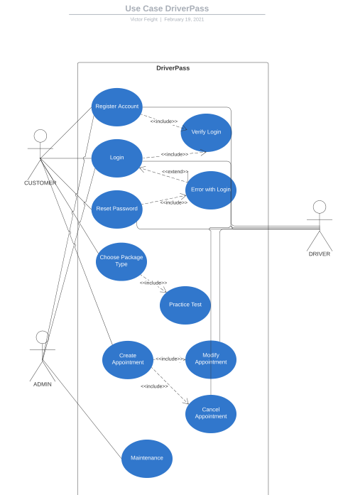

### UML Activity Diagrams

First Diagram (USER)

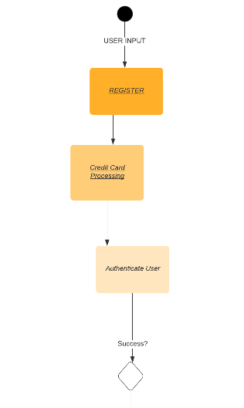

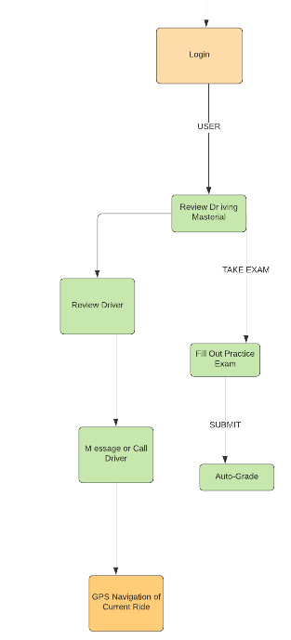

Second Diagram (Driver)

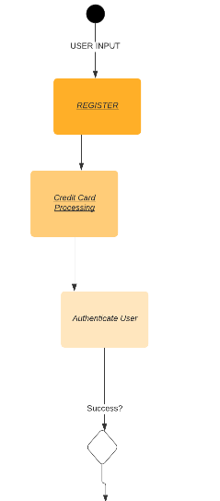

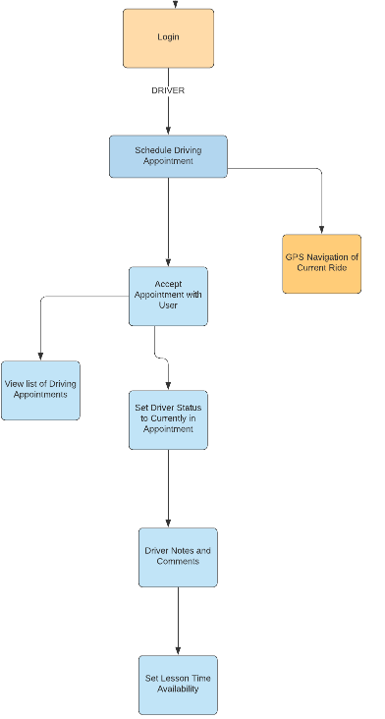

### UML Sequence Diagram

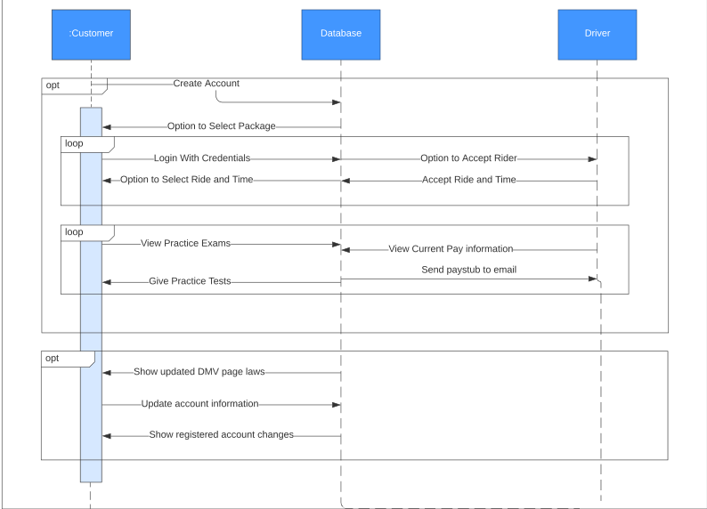

### UML Class Diagram

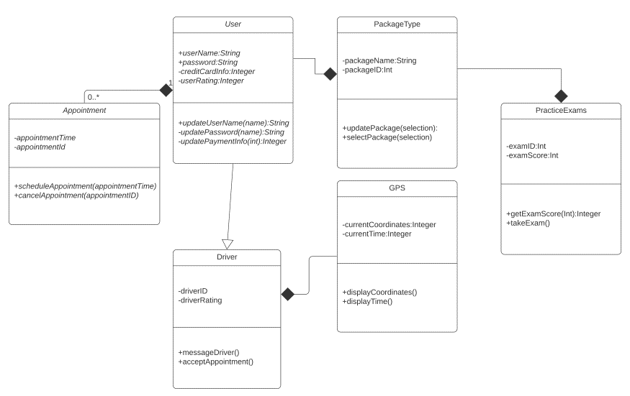

## Technical Requirements

*Required Hardware: Android, PC, Mac for Front end. Linux server is required for the backend.*

*Required Software:*

* Currently browsers on Android redirect to the App Store; Android browser not planned.
* Currently no plans to support Internet Explorer browser.
* Assuming the client is running Firefox, Google Chrome with Javascript enabled.
* It should run as an application in any Android Device. IOS not currently supported but planned for implementation.
* For GPS features to work, Android or PC should have a GPS location function.

*Required Tools:* **REST API with Ruby on Rails** for back-end, **REACT-native-web** for front-end, Javascript must be **enabled**.

*Required Infrastructure:* Currently relying on a more expensive **Amazon AWS** solution for certain *serverless functions* requiring intensive operations, for less throttling.

For Development, any Windows, Mac, or Linux computer with at least 8GB of RAM, at least 2Ghz processing speed recommended.